1. [https://almshell.saas.hpe.com/qcbin/TDConnectivity_index.html](https://emea01.safelinks.protection.outlook.com/?url=https%3A%2F%2Falmshell.saas.hpe.com%2Fqcbin%2FTDConnectivity_index.html&data=02%7C01%7CNaveen.KumarG%40shell.com%7C05b45c6c61d7406fe02908d66f1ac59d%7Cdb1e96a8a3da442a930b235cac24cd5c%7C0%7C0%7C636818559699207710&sdata=qYX%2BHKaWBOcad5jowZj3j%2BMEDXMlIZIvGI%2BBvXNNKqI%3D&reserved=0) to add to your computer the connectivity to ALM. Recommended to have the ALM client installed on the machine running the code
2. If you are using Excel, after point 1) ensure you enable OLE Automation and OTA COM (under Tools/References)

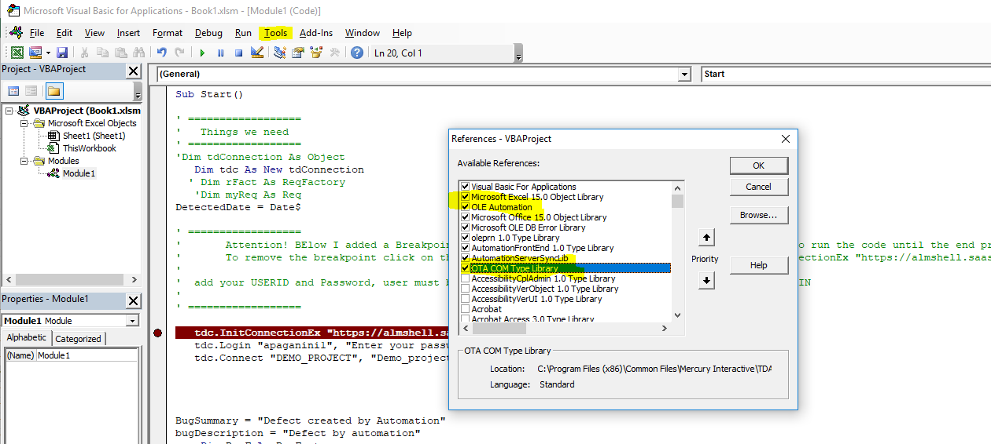

1. Excel example with code to connect (need to enter your userid and password). User must have TDAdmin and assigned to project.
2. **Ensure in your code there is an error management routine that closes the connections. If you don’t you risk of leaving opened connections which (depending on the number) might cause the system to slow down, run out of licenses or crash ALM.**
3. Tables reference is at [https://admhelp.microfocus.com/alm/en/12.60/api_refs/project_db/Content/project_db/topic27.html](https://emea01.safelinks.protection.outlook.com/?url=https%3A%2F%2Fadmhelp.microfocus.com%2Falm%2Fen%2F12.60%2Fapi_refs%2Fproject_db%2FContent%2Fproject_db%2Ftopic27.html&data=02%7C01%7CNaveen.KumarG%40shell.com%7C05b45c6c61d7406fe02908d66f1ac59d%7Cdb1e96a8a3da442a930b235cac24cd5c%7C0%7C0%7C636818559699217718&sdata=d0vSOmJsAGiqFNNFot0u12XNl5Poq%2F9EX%2FXYlWcQ0rA%3D&reserved=0) you can see all the system tables and their fields
4. OTA API reference at [https://admhelp.microfocus.com/alm/en/12.55/api_refs/ota/webframe.html#topic6.html](https://emea01.safelinks.protection.outlook.com/?url=https%3A%2F%2Fadmhelp.microfocus.com%2Falm%2Fen%2F12.55%2Fapi_refs%2Fota%2Fwebframe.html%23topic6.html&data=02%7C01%7CNaveen.KumarG%40shell.com%7C05b45c6c61d7406fe02908d66f1ac59d%7Cdb1e96a8a3da442a930b235cac24cd5c%7C0%7C0%7C636818559699217718&sdata=ogKRsIURNBTXwWKVAGEzasUnMfAiwNWvq5Y44VVb%2FZY%3D&reserved=0) with some examples
5. On the forum you find some example of running SQL via OTA [https://community.softwaregrp.com/t5/Quality-Center-ALM-User/Running-SQL-Query-from-within-Excel-using-OTA/m-p/982919#M12841](https://emea01.safelinks.protection.outlook.com/?url=https%3A%2F%2Fcommunity.softwaregrp.com%2Ft5%2FQuality-Center-ALM-User%2FRunning-SQL-Query-from-within-Excel-using-OTA%2Fm-p%2F982919%23M12841&data=02%7C01%7CNaveen.KumarG%40shell.com%7C05b45c6c61d7406fe02908d66f1ac59d%7Cdb1e96a8a3da442a930b235cac24cd5c%7C0%7C0%7C636818559699227726&sdata=AHmZO1rsa7uKbezukvR9Xk7RRKr6XzZSyU%2BL5cis7Gc%3D&reserved=0)

[https://community.softwaregrp.com/t5/Quality-Center-ALM-User/OTA-How-to-Delete-a-TestSet-from-Lab/td-p/966962](https://emea01.safelinks.protection.outlook.com/?url=https%3A%2F%2Fcommunity.softwaregrp.com%2Ft5%2FQuality-Center-ALM-User%2FOTA-How-to-Delete-a-TestSet-from-Lab%2Ftd-p%2F966962&data=02%7C01%7CV.Kalluru%40shell.com%7C9e5125e2e91849614aec08d6722bb6ef%7Cdb1e96a8a3da442a930b235cac24cd5c%7C0%7C0%7C636821929449977438&sdata=til1Z2eKYKMOCRPcYBpagniszautrKnTikG4HOq1KSg%3D&reserved=0)

[https://community.softwaregrp.com/t5/Quality-Center-ALM-User/How-do-I-delete-all-tests-in-Test-Lab-that-have-the-status-quot/td-p/943934](https://emea01.safelinks.protection.outlook.com/?url=https%3A%2F%2Fcommunity.softwaregrp.com%2Ft5%2FQuality-Center-ALM-User%2FHow-do-I-delete-all-tests-in-Test-Lab-that-have-the-status-quot%2Ftd-p%2F943934&data=02%7C01%7CV.Kalluru%40shell.com%7C9e5125e2e91849614aec08d6722bb6ef%7Cdb1e96a8a3da442a930b235cac24cd5c%7C0%7C0%7C636821929449977438&sdata=QNvQcIOXELGDAV%2BAGSmVTuHwTmZJEzsMLD4%2FcEMN3to%3D&reserved=0)